Team 1:

Team members Name: Allyson McGuire, Sola Lhim

Contributions:

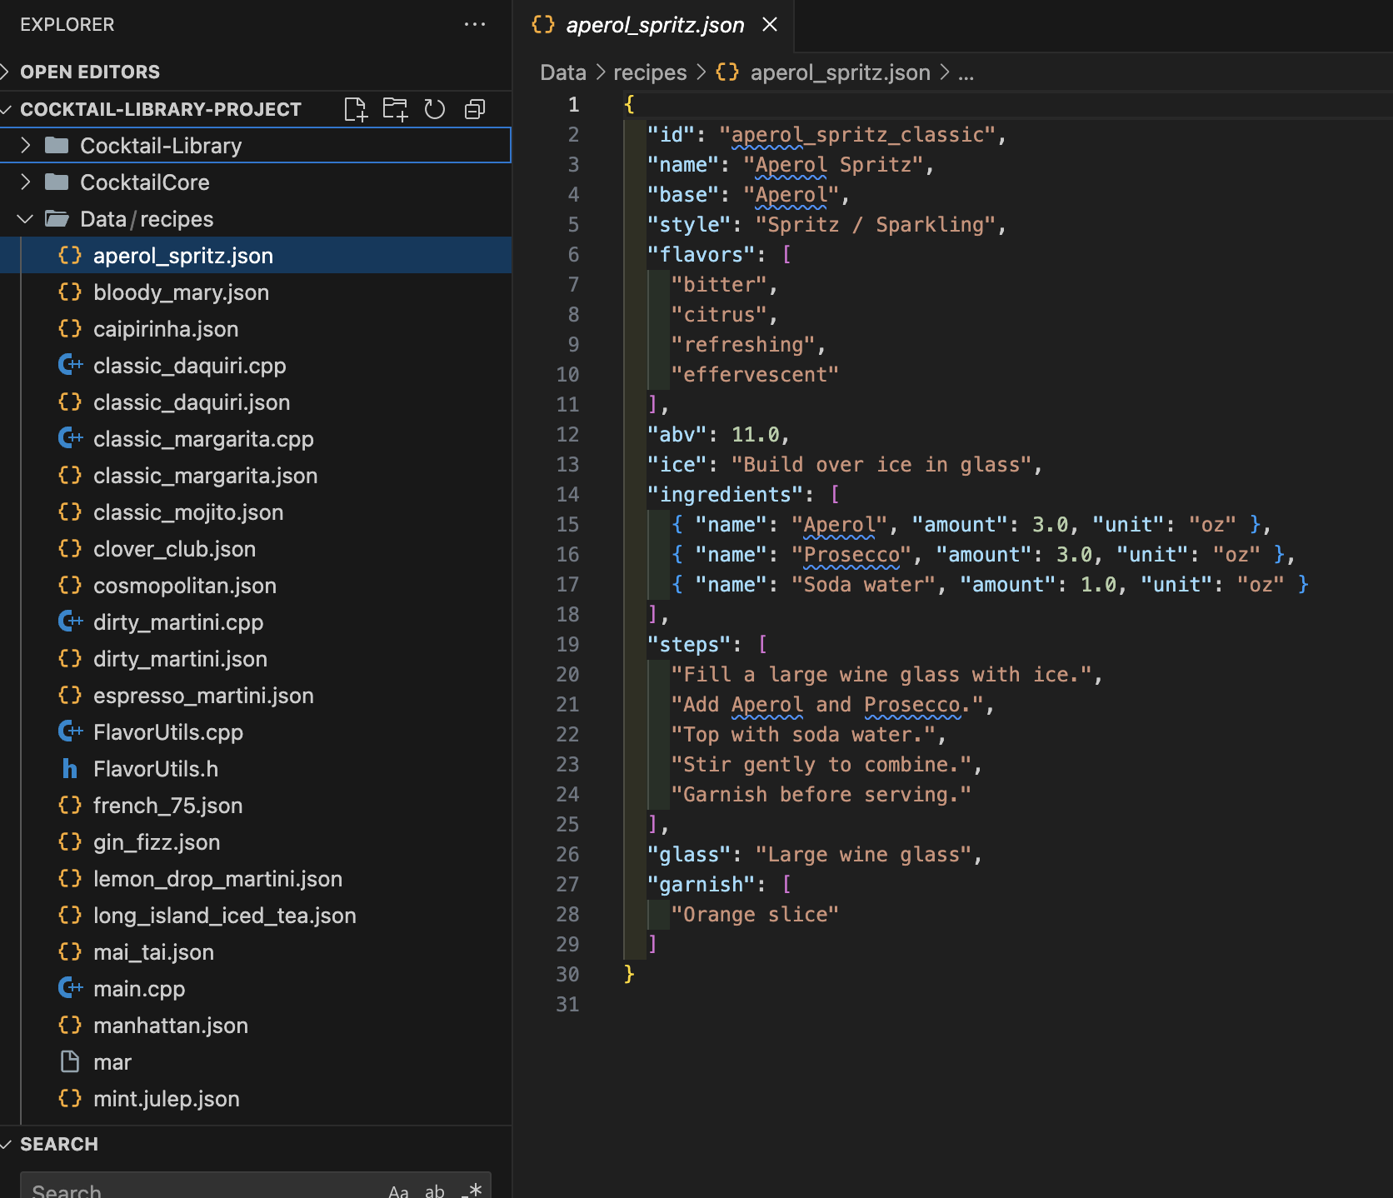
Allyson McGuire - collect “Recipe” seed data in JSON file

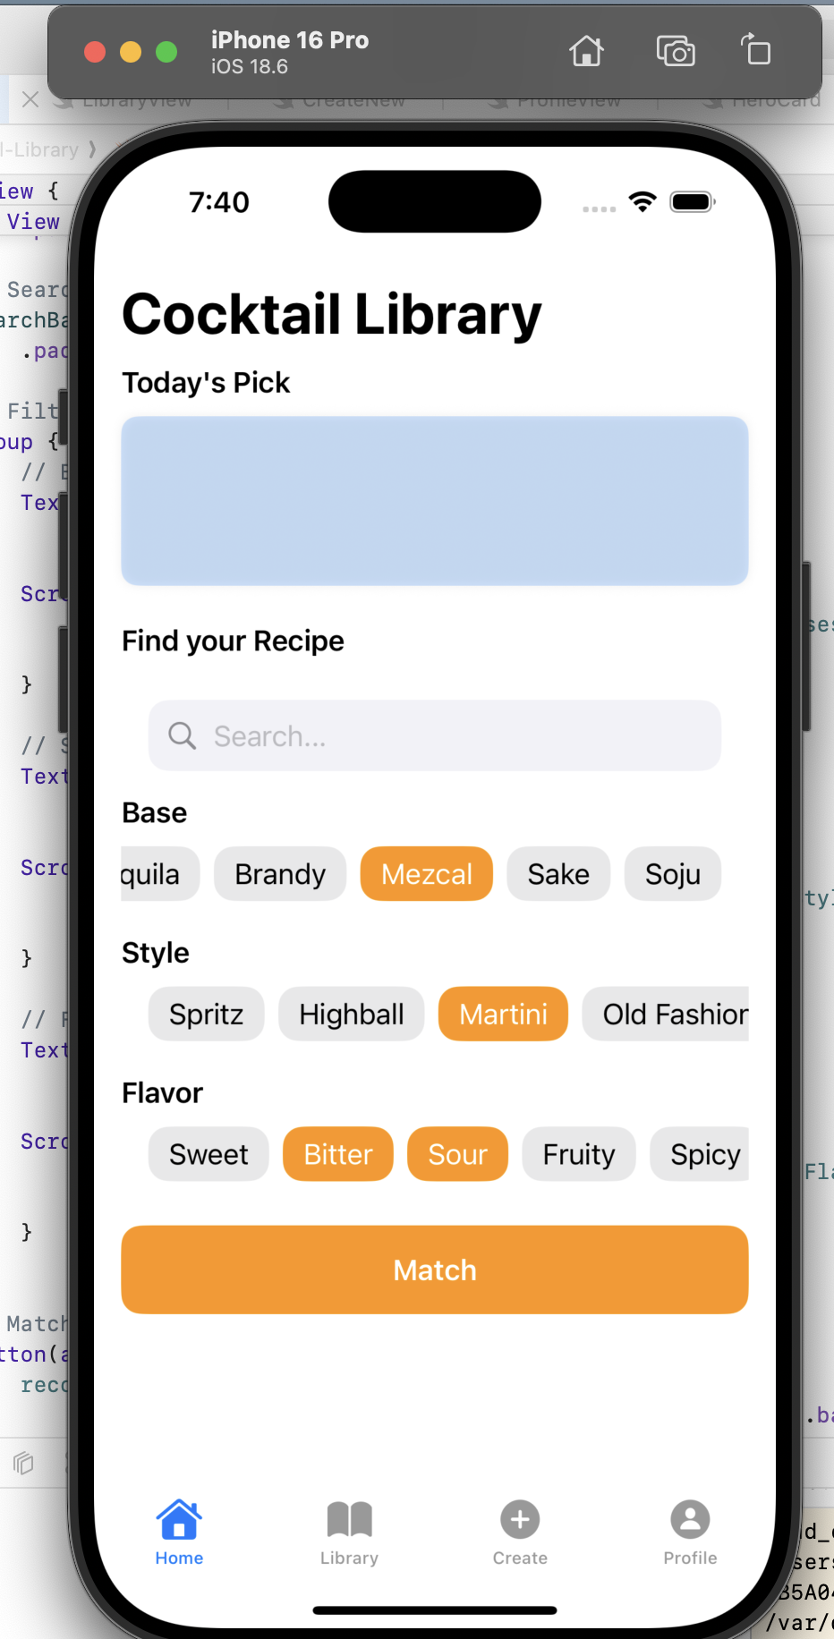
Sola Lhim - Design swiftUI

